**Project Title:** Deep Learning model to estimate land-surface temperature in Israel

**Student Name**: Itay Barkai

**Advisor**: Dr. Oren Glickman (CS, BIU).

Chapter 1:

The goal of this project is to build a deep-learning model to estimate land surface temperature in Israel at a 1x1 km resolution. The Land Surface Temperature (LST) is the radiative skin temperature of the land surface, as measured in the direction of the remote sensor. Historical LST data is available at a 1x1 km resolution, however we would like to see if we can use this data as a target for a deep learning model to learn to downscale temperature data to a finer resolution.

Available Data (For Israel):

* Historical Hourly LST data for the past 20 years. Data includes:
  + lat, long of observation
  + Date & Hour in day
  + LST temperature
* Topography:
  + lat, long
  + height (above sea level)
* Vegetation index from satellite imaging (NDVI) - at a 1x1 resolution
* Additional information (e.g. 9x9 Air temperature, land use, …) may be also available - to be possibly used in the project

[shilo.shiff@biu.ac.il](mailto:shilo.shiff@biu.ac.il) - will provide the data for this project.

Learning Task:

The goal of the deep learning model is to estimate the 1x1 km resolution land surface temperature given the surrounding topography.

For every such 1x1 km pixel, a 9x9 ‘patch’ surrounding the pixel as in the following illustration:

|  |  |  |  |  |  |  |  |  |
| --- | --- | --- | --- | --- | --- | --- | --- | --- |
|  |  |  |  |  |  |  |  |  |
|  |  |  |  |  |  |  |  |  |
|  |  |  |  |  |  |  |  |  |
|  |  |  |  |  |  |  |  |  |
|  |  |  |  | x |  |  |  |  |
|  |  |  |  |  |  |  |  |  |
|  |  |  |  |  |  |  |  |  |
|  |  |  |  |  |  |  |  |  |
|  |  |  |  |  |  |  |  |  |

The overall LST of the 9x9 grid at a given time will be calculated as the average of the 81 LST observations at the same time. Similarly, the average height of the 9x9 grid will be calculated.

The difference between the 9x9 LST and center pixel 1x1 LST will be the target value to predict. Evaluation of the regression problem will be measured via RMSE.

For every such observation, the input to the model will include:

* The Average height of the 9x9 grid
* The average LST of the 9x9 grid
* 81 height diffs (difference between pixel height to the average height for every 1x1 pixel in the grid)
* The day in the the year (0-365, consider transform via sine and cosine)
* The time in the day (0-24, consider transform via sine and cosine)
* lat, long of center pixel
* We may add additional features as we progress (e.g. NDVI

Project work includes finding the optimal feature representation and deep learning neural net architecture (# layers etc, ) as well as analysis of the results.

It is important to test the model on unseen (held out) pixels and dates.

Research Questions:

1. Can you improve RMSE predictions results over the simple baseline of always predicting 0 (temp of 1x1 center pixel identical to the 9x9 average).
2. What is the optimal DL model
3. How the various features impact the prediction

**Chapter 2: Startup:**

Had a Zoom meeting with [shilo.shiff@biu.ac.il](mailto:shilo.shiff@biu.ac.il)

- He helped me understand the project goals and terminology,

- Gave me the LST data for Israel in 2002-2020 (in NetCDF format): <https://zenodo.org/record/4533677#.ZEvTr3ZBwuV>

- Gave me the topography data of Israel as exported from "Google Earth Engine".

- Explained how to work with this format of data in python.

Following that I asked Dr. Oren some clarification questions:

1. More general purpose of the project?

a. Proof of concept for Resolution Downscale

b. Further downscale for LST

c. Downscale air temp

d. Using learned relations of various features for other tasks.

e. General ML research in case of similar records (same place at different times)

2. Pytorch vs tensorflow?

- Up to me.

3. Research common ways to represent "day" and "hour"

- Using cos and sin

4. Requesting access to ML servers for computation and storage that are larger than my home computer.

a. Got a user, and a welcome guide on how to use them.

(Had some back and forth with dsi support to make it work)

**Chapter 3: Learning before and during the project**

To better understand how to code "correctly" and how to use Tensorflow, I've seen freeCodeCamp's 7 hour "TensorFlow 2.0 Complete Course"

- [www.youtube.com/watch?v=tPYj3fFJGjk](http://www.youtube.com/watch?v=tPYj3fFJGjk)

Research some MLOps utils that would help plan the structure and tech stack of the project

- <https://mymlops.com/examples/airflow-mlflow> - this being very close to what I ended up doing.

**Chapter 4: Infrastructure and local environment:**

- I have opened a public repository on my github to better source control the project.

- Multiple folders such as Documents (Project definition, This document), Data and Sources.

- Installed python 3.8.8 Anaconda distribution,

- Ipython 7.22 for easily playing with the data and debugging.

- Decided to use the Tensorflow library (to gain experience in another library)

- Installed it and studied the basics.

Later on finding Git not enough for modern and well documented ML project.

I've research online and also asked Oren about useful MLOps.

Came to conclusion I could use this **stack**:

- "Git" (github) for Code verion control

- "DVC" for Data version control

- "MLFlow" for automated logging of models and their parameters

- (optional) Use TensorBoard for nice visualization of performance.

- logging python library for flow debug logs.

**Chapter 5: Data Documentation:**

- Figured it is recommended to use the netCDF4 library to work with the NetCDF LST files.

- Got familiar with the library, with the data format.

- Using ipython, and the data's documentation here: <https://zenodo.org/record/4533677#.ZFDyHHZBwuX>

Figured the format of the actual data in our NetCDFs

**The LST Data:**

Consists of NetCDFs for each year between 2002-2020.

Each one should have 2 samples per day of the LST on each 1X1 block in Israel.

Practically each NetCDF has 5 variables named: ["y", "x", "band", "time", "__xarray_dataarray_variable__"]

**"y"** = latitude, **603** points between 28.996716325654262 and 34.00777509644337

**"x"** = longitude, **409** points between 33.20034536095077 and 36.59654466075468

**"band"** = 4 values (channels):

NIGHT_LST = 0

DAY_LST = 1

DAILY_LST = 2 (average of 2 previous ones)

QA = 3

QA means if there were clouds that interrupted the actual sample and the data is generated from a previous model: (<https://zenodo.org/record/4533677#.ZFkQRHZBwuX>).  
The values in the QA band represents:

NO_DATA_BOTH_DAY_NIGHT = 0

NO_DATA_DAY = 1

NO_DATA_NIGHT = 2

BOTH_VALID = 3

**"time"** = day in the year for the sample – from 0 to 365 (366 in leap years).

There might be skips in time in days that for some reason did not have a sample.

**"__xarray_dataarray_variable__"** = The actual LST value for each combination of the above variables.

Has shape of (364, 4, 603, 409) – (for example in 2020)

* Notice the time variable has 364 instead of 366 (leap year) because 2 samples are missing.

This is a numpy masked array which means it may have invalid data (like NaN).

For example in a single specific day there were 170k out of 240k valid values.

**Data Invalidity**

As said, the data might be invalid/missing in some 1x1 spots on the grid.

We need to decide how to treat such data points, while we want to make samples out of a 1x1 spot and its 9x9 surrounding cell.

After looking for patterns in the invalidity of the data, it was said the data should only be invalid in the seas.

So I printed the validity of True/False as White/Black of 2 days:

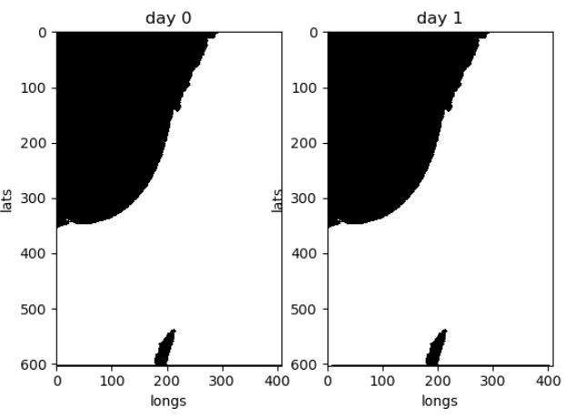

Aside from about 10-30 points the validity map is the same between days and it looks like a ground-sea map of Israel.

Overall it means we can use only 1x1 spots with a valid 9x9 surrounding and it should work fine.

**The Topography Data**

Queried and exported from "google earth engine", in .tiff format that has a numpy array. Can be read with python's tifffile.imread.

The dataset I received had the wrong resolution, as its shape was 379x559, when the LST's shape was 409x603. That would make it impossible to align the correct elevation to a sample.

In order to generate a correct resolution topography dataset I had to figure exactly how to LST dataset was made to recreate it in the google earth engine query.

In the LST data:  
latitude, 603 points between 28.996716325654262 and 34.00777509644337  
longitude, 409 points between 33.20034536095077 and 36.59654466075468

Found the length of the north and south borders to be 313km and 330km respectively, meaning the distance between each LST sample is changing.

After checking the difference between each longitude/latitude (in degrees), they were all equal ~1/120 of a degree :

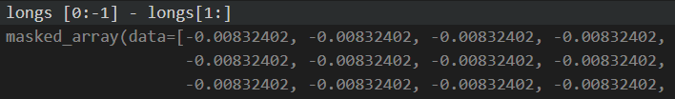

From the commonly used NASA topography dataset "USGS/SRTMGL1_003" it is documented to have resolution of arc-seconds (1/3600 of a degree), so rescaling 30x30 pixels to each output pixel is about right and possible.

I confirmed it by clipping the dataset to a rectangle within the bounding degrees of the LST data, and received shape (12228,18041), that matches: (max_degree-min-digree)/pixels ~= 1/3600.

I wrote a script in Earth Engine to scale this rectangle topography to dimensions of 409x603 just like the LST shape and exported a good looking .tiff file. (Script is saved near the data file)

Its min height is -415 and max height is 2687, which correctly describe the Dead Sea and the Hermon heights.

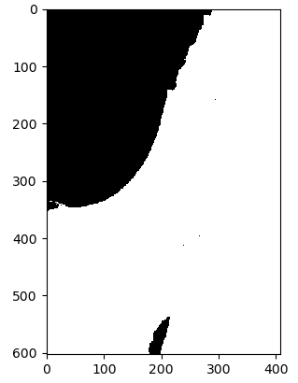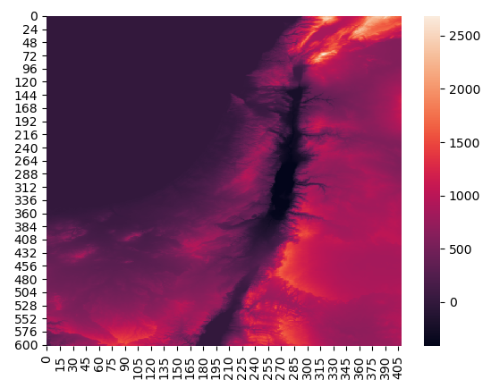ax.imshow(image==0, cmap=plt.cm.binary, interpolation='nearest')  
sns.heatmap(image_f)

**DEBUG SECTION**

in ipython run and then play with the outputs

%run ./main.py

Can also use debugging with breakpoints in vscode

**TODO SECTION**

**add height reads**

**add height to dataset (how? 9x9, maybe only center-mean is enough)**

**make the 3 wanted predictors.**

**calc RMSE of mean returner**

**plan normalizing for data**

**- if dynamic by current data range might make different RMSE between datas**

**- might be ok different RMSE and calc 3 returners for each data change**

**- same normal for mean and center (keep relations), do by centers? standardize**

**- day - https://ianlondon.github.io/blog/encoding-cyclical-features-24hour-time**

**try simple model for completed 5 day dataset**

**graph 3 returners loss per epoch (mean should be horizontal line)**